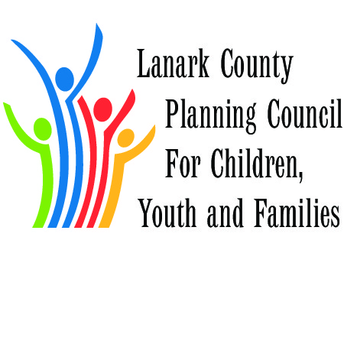
December 4, 2015 Planning Day Summary and Suggested Actions

Our Successes and Strengths
The Lanark County Planning Council for Children, Youth and Families has enjoyed some terrific successes over the past years. The listing of projects and accomplishments is amazing in the depth of the work, the breadth of the span across sectors and the inclusion of fun to serious topics! We have an incredible collective strength, and we are able to identify ways to improve, specifically with community engagement, member diversity and inclusion, identifying that we have room to grow in handling controversy, and are able to embrace new ways of working together to improve our planning table. To be noted is a comment from one of our facilitators who was so surprised that the group was so “quickly willing and eager to engage and respectfully participate! What partnership!”
Suggested Action: Continue to build on our individual and collective strengths and stretch our thinking to reach ahead into new territory.
Clarity of Purpose
We soon discovered that our goals, objectives and purposes are all connected, and it is hard to do one without the other. Planning and evaluation is our first objective, but we recognize that it is difficult to find commonality sometimes and there are barriers to working together, even if we all serve the children and youth of Lanark County. There is a continued need to speak in a unified voice as we advocate for the most vulnerable, and a desire to find ways to use our combined clout in order to have a collective impact. We have a desire to engage families, clients and partners in a more meaningful way to further develop service integration, and to build on our diverse knowledge outside of agency, funder and program siloes and geographic boundaries. We want to be seen as the “go to” network when others are talking about kids, and community education is the way the Council will become better known in Lanark County. We agreed that we all appreciate the information sharing aspect of the Council, but we have to move beyond information and into action. In the same way, professional development is seen as what we all do and is not such a collective focus as it might have once been.
Suggested Action: Prioritize the LCPC goals, objectives and purposes, so that we work collectively on planning and evaluation as well as on advocacy, service integration and community education; put less emphasis (but not forget) on information sharing and professional development; prioritize the developing work plan accordingly.

Our Stumbling Blocks
The naming of our stumbling blocks that were identified by facilitators from the morning discussion and some background materials were a bit of a surprise for some members.: How we work effectively with Tri-County agencies, how we promote diversity and inclusion at our planning table, and how we move from discussion to action were seen as things that get in the way of the Council moving forward, and some great discussion took place within our “wise crowds” on how we can move beyond these blocks. While these were “mock” stumbling blocks quickly gleaned from various discussions on other topics, they provided a process to talk about a difficult subject without judgement or blame assigned.
Suggested Action: These are the first of some difficult conversations that need to take place at LCPC. We need to clearly identify when we see a stumbling block get in the way, and be prepared to talk about it in a non-threatening and productive way so we can move forward. Is this an acceptable process?

Our possibilities
When we clearly thought about what we needed to stop doing so we could make room for innovation, three areas came rose quickly for discussion. We identified communication, our work on poverty and our LCPC meeting structure and agendas as very specific areas where innovation and change is possible.
Suggested Action: Ask our communication committee to revise their communication plan; review and revise our meeting structure and agendas; consider our work on poverty!
Our Partners
The mapping of our organizations by key partnerships showed that we are missing some of the key partners (sector, agency, program and community) of our member agencies. The priorities of our member agencies were difficult to analyze, and the listing serves as information.
Suggested Action: Consider the composition of the membership and invite or engage those missing as appropriate; develop a new way to track priorities of member organizations to find new ways and places to partner effectively.

Our Goals
We had a “bike rack” or “parking lot” available all day where priority work areas were identified, including the special needs strategy, rural funding, children’s mental health transformation and collective impact. When asked what people were specifically passionate to identify as goals for collective work in the next 2 years, the group quickly identified 4 areas including Community Engagement, LCPC Momentum, Acting on Poverty, and Special Needs and Developmental Services – Respite Expansion.

Suggested Action: Reconfirm goals identified and look for concrete steps to move forward; consider what is actionable and possible; consider working from a practical place ie Bridges out of Poverty Workbook; consider the questions – Is this the job of the Planning Council, and is it work that moves us forward within our purpose

Action Planning
Within the context of the planning day discussions, partners were asked to think about making a change that mattered, and a first step to achieve that change, and these bold ideas were ranked. Topping the polls were changes in LCPC meetings, community engagement, overcoming barriers (diversity and inclusion), developing share/care homes for children with complex special needs, and the elimination of poverty! The changes were very similar to the goals and priorities that were common themes throughout the day, and the bold ideas and first steps were the vision and absolute concrete beginning of a work plan!
Suggested Action: When goals are adopted, include the bold ideas and first steps in the work plan.

