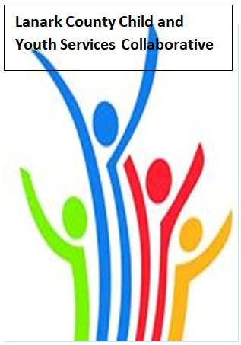

Vision: Children and youth in our communities are thriving. They are served by a well, informed, responsive and effective community of organizations.

Mission: The council provides leadership and collaboration to enable optimal development and healthy living for Lanark County children, youth and their families.

Coffee provided by Family & Children’s Services
We meet on traditional unceded Algonquin First Nation Territory, in Lanark County.

NOTES
Dec. 5, 2019 9:30 – 12:00 – Family and Children’s Services of Lanark, Leeds and Grenville, Smiths Falls, ON
Chair: Fraser Scantlebury Coordinator: Sharon Halladay Note Taker: Cathy Clarke
Attendance: Jane Hess, Kara Symbolic, Randy Hillier, Margaret van Beers, Kevin Clouthier, Cliff Woods, Meghan Roebuck, Erin Lee, Erin Lee Marcotte, Hayley Stolarchuk, Rachel Rotin, Natalie Markoff,
Regrets: Kelly Robinson, Sue Cavanaugh, Stacie Dowdall, Sue Polervaart, Paul Birley, Erika Heesen, Lisa Benoit
Agenda item | Desired outcome | Lead | Time | Discussion and action items
Welcome  - Review Agenda  - Acceptance of Meeting Notes |  | Fraser Scantlebury | 9:30 – 9:40 | Agenda Ok  Note from Nov. 7 OK
Information Sharing | Share information/  PD opportunities | Participating Members | 9:40 – 10:05 | Kara - 16 registered for youth gathering. Youth Hub centre in Perth. Transportation $1400 to get everyone there and back.  Jane – dental health program launched. 19 patients so far. Expanding sites to Westport, Brockville – waiting for approval. Transport included.  Kevin – Continuing parent information sessions, walk in clinics in addition to regular programs. Attended workshop worked on 5 pillar protocol.  Rachel – working on strategic plan, everything open, Most successful program was movie night. Hosted Babysitter’s course, wait list for the next one  Cliff – Dates to remember Christmas Party December 8,  Fund raiser Feb. 29 – bowling  Mentorship program – March 24 – 26  Check website for information  Meghan – finalized strategic plan found it inspirational. Getting 30-50 kids per day. Gearing up to feed them.  Erin – Dec. 6 30th anniversary of Montreal tragedy 3 vigils. Smiths Falls Hospital, Trinity United Church, Woman’s monument Perth.  1st anniversary of 2nd stage housing, all units full , Waitlist for this. Funding received, hiring victim advocate position. Working on text tool. Evening of music and comedy Jan 11 PDCI.  Haley – Autism training 3 days. New service provision in Carp. Haley to send info to Sharon.  Erin Lee Marcotte – engaging in strategic plan. Stretched staffing Executive Director finished end of March.  Margaret – Email Margaret if want to attend session being offered re co-ordinating service plan.  Fraser – Dates to remember – Planet Youth Lanark County media advisory Announcement about UCDSB MOU signing, Dec. 17; Jan 20 – open community Launch Event with guests from Iceland, Zion Memorial Church, Carleton Place 7PM; Jan. 31 9 AM – 3hr workshop with experts from Iceland on the overall process from survey to results – included lunch – please contact Fraser to register; United Way - Jan 25 Annual Almonte Toy & Collectible Show 10AM to 2PM Almonte Civitan Club.  Dean sent regards hopes to be at Feb. meeting
Community Education |  | Randy Hillier | 10:05-10:30 | Randy gave a 30 minute presentation. Lively question and answer period followed.
Collaboration and Planning | Break |  | 10:30– 10:45
Community Education |  | Natalie Markoff  PLEO  Communications and Partnerships Director | 10:45- 11:10 | Natalie gave a very informative presentation on PLEO and asked for questions. Help for parents and caregivers offered by this program. Assistance is offered in French and English. PLEO has no wait list.
Collaboration and Planning/Advocacy | Work plan Review  Dec. Survey | Sharon Halladay | 11:10 – 11:50 | Discussion on presentation of wordle. Survey completed. Work plan completed for Sharon to collate.
Community Issues Update  Key Messages and Closing |  | Erin Lee  Fraser Scantlebury | 11:50– 12:00 | Erin reported that no community issues meetings have taken place.  Great cookies and fudge  Engaging presentation with Mr. Hillier  Natalie’s presentation  Thanks to Margaret for bringing issues up re Kids Inclusive  Erin – good to look at all accomplished as a group  Haley – Autism help families, educate parents – will forward document to Sharon.  Next meeting February 6, 2020

