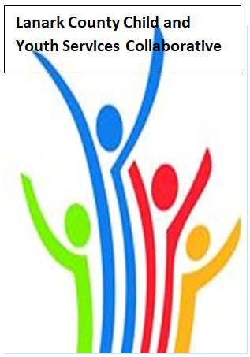

Vision: Children and youth in our communities are thriving. They are served by a well, informed, responsive and effective community of organizations.

Mission: The council provides leadership and collaboration to enable optimal development and healthy living for Lanark County children, youth and their families.

Zoom provided by United Way
We meet on traditional unceded Algonquin First Nation Territory, in Lanark County.

AGENDA
July 7, 2020 9:30 – 11:00 –Virtual Zoom
Chair: Fraser Scantlebury Coordinator: Sharon Halladay Note Taker: Sharon Halladay
Attendance:
Regrets:
Agenda item | Desired outcome | Lead | Time | Discussion and action items
Welcome  - Review Agenda  - Acceptance of Meeting Notes  - Succession Planning New Chair for fall |  | Fraser Scantlebury | 9:30 – 9:35
Community Education | Legal Clinic | Beth Schilling  Community Outreach Worker | 9:35-10:25
Information Sharing | Share information/  PD opportunities | Participating Members | 10:25 – 10:45
Community Education | Black Lives Matters | Fraser Scantlebury | 10:45-10:55
Key Messages and Closing |  | Fraser Scantlebury | 10:55– 11:00
Next Meeting: Aug. 13, 2020

