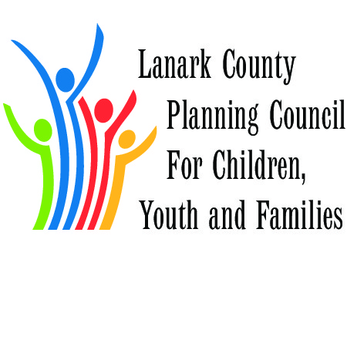

MINUTES
February 5th, 2015
9:30 – 1200 hours
Lanark County Council Chambers

Thanks to Smiths Falls Community Health Centre for refreshments

Call to Order – welcome and regrets
Present:
Elaine Murkin, Sara Hammel, Tanis Cowen, Fraser Scantlebury, Mona Wynn, Cliff Woods, Jennifer Miller, Susanne Geoffrion, Carol Anne McNeil, Donna Davidson, Ramsey Hart, Allan Hogan, Jane Torrance, Sue Poldevaart.

Also present, attending the CHEO/Royal Consultation: Lissa Greenwood, Tania Cull, Martha Duncan, Stacey Shanks, John Fenik

Regrets:
Pam Harris, Margaret Van Beers, Dave Murphy, Mary Lou White, Michelle Neville, Sue Cavanagh, Darrell Dean, Jane Hess

Approval of Minutes:
Minutes of February 5th, 2015 were seconded by Fraser Scantlebury, as posted to lanarkkids.ca

Approval of Agenda
Agenda was approved as presented, seconder Jennifer Miller, with the addition of Reports if necessary

Business Arising
Planning Day Report – Jane presented an 11 point document for discussion, as a focus for the next 3 -4 years

Case Presentation
Mona spoke of the Community House on Empress Street, Smiths Falls. She gave background information on the acquision of the house and a description of the population served. A meeting is planned for Feb. 17th.
Several comments given were very positive about the service provided

Big Data for Small Places – process
Jane reported that clarification is needed. She provided a list for discussion. Open Doors lead agency. Partners named: Algonquin College, Open Doors, North Grenville, Mississippi Mills, Planning Council

ANNOUNCEMENTS
Looking at Seniors program – Strategic Plan March 24. Volunteers needed.
TriCAS amalgamating
Page 2
Minutes Feb. 5/15
Lanark County Planning Council

Yak – 2 day training available for $30. Interested persons contact Tanis
Feb. 11, 2015 211 day – raise awareness
Thrive – supporting women with opiate issues. An art project is planned. Child care available
Bowl for Kids – 2 weeks away
New Executive Director will be named for Open Doors in near future
Long respite wait list. Fund raiser Feb. 26
Income tax volunteers available through Lanark Community Programs

Planners Report
- Best Start – key messages from January
  - Twitter Walk – “How to”
  - Importance of Parent Engagement
  - Discussed Language Registers as related Bridges out of Poverty.
  - Ideas to have continued open conversations and dialogue at meetings
- Municipal Drug Strategy – next networking day is scheduled Friday, Feb 27 8:30-1:00 (including lunch) and the topic is Enforcement. Confirmed speakers include the SF Police, RNJ, Crime Stoppers, UCDSB and CDSBEO. Registration is $10. Register at http://mdsnetworkday.eventbrite.com
- Big Data for Small Places – risk management has been addresses; Open Doors has been identified as the lead partner
- Triple P – meeting has been rescheduled to Feb 11, 2:30 – 4:00 in Tay Valley Rm, Lanark County offices in Perth
- Planning Spring training (April 27 and 28) on Strengthening Network and Liberating Structures with Liz Rykert (http://www.metastrategies.com/ ) tentatively scheduled to take place in Smiths Falls at Gallipeau Centre with a Regional invitation, including L-G, KFLA, HPE, Ottawa and Renfrew
- Special Needs Strategy – a tab has been added to our web site http://lanarkkids.com/special-needs/ and I will post information, questions, reports etc to site as required, as well as to social media. All questions are directed to llgspecialneedsstrayegy@gmail.com
- Upcoming Meetings to note
  - OPP Mental Health Consultations on Feb 12 – by invitation only (although none have been issued yet!)
  - Stewardship meeting on Feb 18
  - Local Immigration Partnership – March 3

NEW BUSINESS

Attending from the Royal, Dr. Smita Thatte, from CHEO Dr. Kathi Pajer, Shannon Watson

Dr. Pajer asked three questions of the Planning Council
- What do CHEO and the Royal do well now
- Where are areas that both hospitals can do better
- Action Plan
A great many ideas were shared – main focus, lack of transportation to appointments, no inhouse services for very sick children
Things the hospitals could do better: clarity in access process
How to get to primary care for effective care of children
No access the physicians
Include addictions in the mental health care plan
Transitions from children to youth in terms of care

Jane to send EdI information to Shannon as well as information on consumption of alcohol stats.

Doctors will speak with new pediatrician in Almonte, look at a clear referral process, inhouse treatment, onging commitment to rural areas.
Report on this session will be posted on Cheo and Royal websites.

Adjournment 1200 noon

Next Meeting scheduled for

Recording Secretary Cathy Clarke

