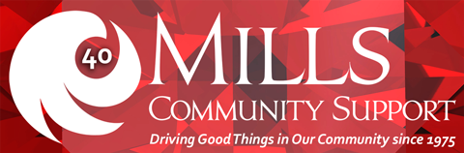
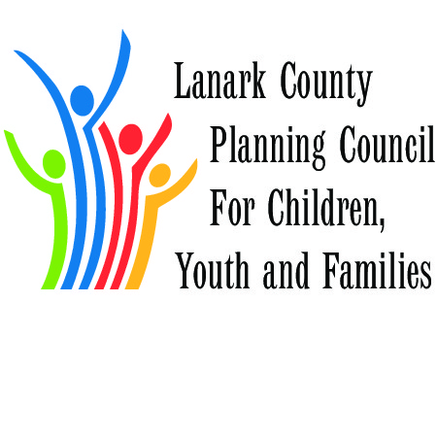
Federal Election Candidates
COMMUNITY CONVERSATIONS
Tuesday, September 29 from 12:30 – 3:00
Carambeck Community Centre, 351 Bridge Street, Carleton Place
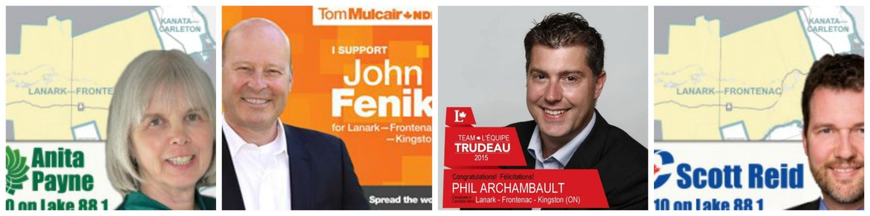

Come talk to the candidates about issues that matter to you

This is not a candidate’s debate. It is a round-table conversation with members of the community. Let your voice be heard by your candidates.
Concerned about social issues like housing, income, healthy, families, diversity and social justice? Come talk to the candidates and let your voice of real experience be heard in this round-table format discussion.

Real talk with real people, by invitation.
#yourvotematters

