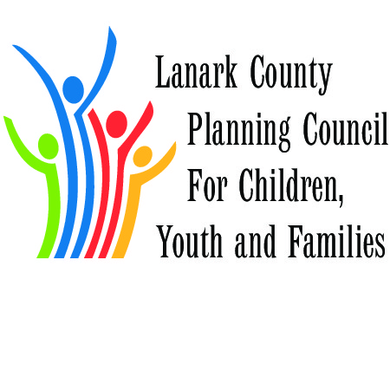
Why we are Great!
62 Reasons and Counting Why we were Awesome
September 2015 to September 2016

Assets –building on what we do well; continue to build on our individual and collective strengths and stretch our thinking to reach ahead into new territory.

Communication
- Social media is awesome!
  - Facebook - frequent posting of partner’s information; 127 “likes” and frequent shares
  - Twitter - frequent posting of partner’s information ; 340 followers and almost 300 tweets
  - Website – frequent posting of partner’s information and 6,631 views in past year
  - Training modules uploaded onto lanarkkids so people can learn at their own pace
  - Twitter workshop provided to a partner’s work team

Community Issues/Advocacy
- Community Conversations with Candidates – round table discussions about social issues with federal election candidates
- Truth and Reconciliation focus
  - Adoption of TRC Commitment
  - Gathering – TRC in Lanark County
- Postcards to Atiwapiskat

Collective Impact
- Poverty Reduction Committee organized
- Collective Impact and Building Collaborative Organizations Series: Four excellent session were held :
  - Collective Impact Forum facilitated by Linda Grauper
  - Collaborative Organizations Symposium facilitated by Liz Rykert
  - Culminating Meeting facilitated in-house by Jane, Fraser, Mike Results: A revitalized Liberating Structures Users Group, an Employment network , a transportation working group
- Situation Table – a collective impact project
- Youth Collective Impact Project focussing on Youth Homelessness

Engagement
- Community Conversations with federal candidates
- Survey and discussion with partners re Community Hubs
- Journey to Truth and Reconciliation

Meeting and Agenda Organization
- Prioritized Actions
- Presentation from Every Kid (Leeds Grenville) on how they organize
- Ad Hoc and Working Groups identified from Prioritized Actions
- Goals review
- FCSLLG agreed to fund refreshments and admin

Mandate Review
- Reviewed and Adopted updated Terms of Reference
- Annual review

Aboriginal Services
- Aboriginal partnership reflection
- Community Issues WG committed to review of TRC and Calls to Action
- Aboriginal Planning template submitted to EDU

Service Integration
- Youth Homelessness
  - Youth CI
  - Pathways to Care presented by Jacqui Robertson
  - A Way Home strategy by Lanark County and Cornerstone Landing
- Special Needs Strategy
  - Ongoing multi-partner strategy led by Margaret
- Application to Rural Ontario Institute for Measuring Rural Vitality– this was ultimately denied, but we had new partners come forward to work on this project
- Nature4Life
  - Multi-partner approach led by Healthy Community Partnership
  - Risky Play initiatives
  - Materials were distributed for posting in offices;
  - New facebook group was been established
- Community Hubs
  - ad hoc committee and survey – who sees themselves as a Hub
- Youth Collective Impact
- Successful Projects supported by Best Start
  - Baby Talk (CROW/ Libraries)
  - OT Consults (Child Development Centres at Hotel Dieu and CHEO and LCP)
  - 18month Well Baby visit (Health Unit and
  - Culture, Context and the Mental Health and Psychosocial Well-being of Syrians
  - Expanded OT/PT/Speech Consults (CTC in Kingston and Ottawa, Language Express, LCP)
  - ACT Training for adoption permanency (FCSLLG and Open Doors)
  - How Learning Happens (Daycares and CROW)
  - Triple P in Schools (Health Unit and UCDSB)
- After School programming in Lanark County
  - 6 LCPC members working together – BBBS, Rideau Community Health, YAK, United Way, Lanark Youth Centre and North Lanark Health Centre
  - Serving 11 area schools
  - With 4 private sector partners – Canadian Tire SF, Canadian Tire Perth, JumpStart, RBC
  - Helping 300 children a year
- Triple P
- Bridges out of Poverty

Professional Development
- Collective Impact Webinars
- Municipal Drug Strategy Networking Days
- Bridges out of Poverty
- Strengthening Networks and Liberating Structures
- Liberating Structures Users Group established and meeting
- Twitter Walk
- Social Media training and modules developed and posted to website
- LELCA events
  - How Learning Happens

.

