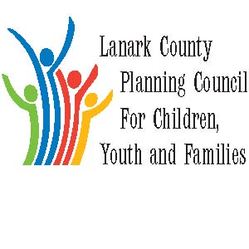

AGENDA

Oct. 4, 2018 from 9:30 – 12:00

Family and Children’s Services of Lanark, Leeds and Grenville

385 Hwy. 29 Smiths Falls, ON

Refreshments and administrative support provided by Lanark County/Family & Children’s Services

The Council provides leadership and coordination to enable optimal development and healthy living for Lanark County children, youth (0 – 18 years of age), and their families. The Council is committed to providing leadership and innovation in the following areas: Service integration, advocacy, planning and evaluation, information sharing, community education and professional development.

We meet on traditional unceded Algonquin First Nation Territory, in Lanark County.

Agenda Item | Responsibility | Time
Opening- welcome and regrets;  Sharing - Announcements, Information, and Professional Development opportunities  Approval of Minutes  Approval of Agenda including questions on updates | Chair – Kevin Clouthier | 9:30-9:50
Presentation  - SFDCI – Tell Them From Me Survey | SFDCI Students | 9:50 – 10:15
Business Arising  - Location of Meetings  - Donna- Retirement | Kevin Clouthier | 10:15 – 10:20
BREAK |  | 10:20 – 10:40
Presentation  - Lanark Transportation | Marilyn Bird | 10:40 – 11:05
LCPC Coordinator  - Report – Key messages | Sharon Halladay | 11:05 – 11:15
Reports  - Community Issues  - Stewardship | Erin Lee  Kevin Clouthier | 11:15 – 11:20
New Business  - Orientation Package  - Election | Sharon Halladay  LCPC members  Kevin | 11:20 – 11:40
Key Messages and Closing of Morning Session | Chair | 11:40 – 11:50
Next Meetings: Nov 1/18
- Do we have a Dec. meeting?
- Should January be the 3rd or 10th?

Attachments to this agenda include:
- Minutes of Sept. meeting
- Orientation Package- Please review and come to meeting with suggestions.

