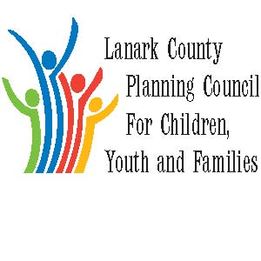

AGENDA

May 3, 2018 from 9:30 – 12:00

Lanark County Administration Building

99 Christie Lake Road

Refreshments and administrative support provided by Lanark County

The Council provides leadership and coordination to enable optimal development and healthy living for Lanark County children, youth (0 – 18 years of age), and their families. The Council is committed to providing leadership and innovation in the following areas: Service integration, advocacy, planning and evaluation, information sharing, community education and professional development.
www.lanarkkids.com twitter: @lanarkkids www.facebook.com/lanarkkids

We meet on traditional unceded Algonquin First Nation Territory, in Lanark County.

Agenda Item | Responsibility | Time
Opening- welcome and regrets;  what we appreciate  Sharing - Announcements, Information, and Professional Development opportunities  Approval of Minutes  Approval of Agenda including questions on updates  Celebrating Successes | Chair  Mary-Lou | 9:30-10:00  10:00-10:10
Business Arising  - LCPC moving forward – update | Stewardship | 10:10-10:20
BREAK |  | 10:20-10:35
New Business  - Health Unit data  - Open Space | John Cunningham | 10:35-11:05  11:05-11:45
Reports if necessary:  - Regional Process (MCYS)  - Planner’s Report  - Stewardship | Darrell Dean  N/A  Chair | 11:45-11:50
Emerging Issues |  | 11:50-11:55
Upcoming Agenda Items –

Key Messages and Closing | Chair | 11:55 – 12:00
Next Meetings: May 3, June 7, Sept 6, Oct 4, Nov 1, Dec 6

Attachments to this agenda include:
- Minutes of March meeting

