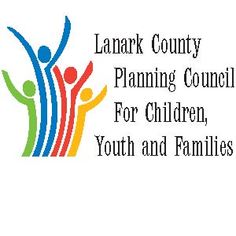

AGENDA

Nov. 1, 2018 from 9:30 – 12:00 p.m.

Family and Children’s Services of Lanark, Leeds and Grenville

385 Hwy. 29 Smiths Falls, ON

Refreshments provided by County of Lanark/Family & Children’s Services
The Council provides leadership and coordination to enable optimal development and healthy living for Lanark County children, youth (0 – 18 years of age), and their families. The Council is committed to providing leadership and innovation in the following areas: Service integration, advocacy, planning and evaluation, information sharing, community education and professional development.

We meet on traditional unceded Algonquin First Nation Territory, in Lanark County.

Agenda Item | Responsibility | Time
Opening- welcome and regrets;  Sharing - Announcements, Information, and Professional Development opportunities  Approval of Minutes  Approval of Agenda including questions on updates | Chair - Sue | 9:30-9:50
Business Arising  - Signing of Participation Agreement  - Approval of Membership Package  - New Membership  - Strategic Planning- Worksheet  - Election | Chair- Sue  Sharon Halladay | 9:50 – 10:10
Presentation  - Planet Youth | Kevin Clouthier  Brenda McDonald-Rowe | 10:10-10:35
BREAK |  | 10:35 – 10:55
Presentation  - Lanark County Data Sharing Network | Lynn McIntyre/Kara Symbolic/Erika Heeson | 10:55 – 11:20
LCPC Coordinator  - Report | Sharon Halladay | 11:20– 11:22
Information Item  LHIN level of service concerns | Terri Mullins  LEIP | 11:22 – 11:32
Reports  - Community Issues/Municipal Election Update  - Stewardship | Erin Lee  Sue Poldervaart | 11:32 – 11:50
Key Messages and Closing of Morning Session | Chair | 11:50– 12:00
Next Meetings:
Dec. 6, 2018
January 10, 2019
February 7, 2019

Attachments to this agenda include:
- Minutes of Oct. meeting
- Coordinator Key Messages
- Revised Membership Package
- LCPC Priorities Session Worksheet
- Draft Memorandum of Understanding from the Lanark County Data Sharing Network

