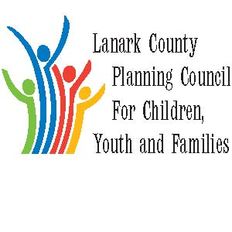

Vision: Children and youth in our communities are thriving. They are served by a well, informed, responsive and effective community of organizations.

Mission: The council provides leadership and collaboration to enable optimal development and healthy living for Lanark County children, youth and their families.

Refreshments provided by County of Lanark/Family & Children’s Services
We meet on traditional unceded Algonquin First Nation Territory, in Lanark County.

AGENDA
March 7, 2019 9:30 – 12:00 – Family and Children’s Services of Lanark, Leeds and Grenville, Smiths Falls, ON
Chair: Kevin Clouthier Coordinator: Sharon Halladay Minute Taker: Sharon Halladay
Attendance:
Regrets:
Agenda item | Desired outcome | Lead | Time | Discussion and action items
Welcome  - Review Agenda  - Acceptance of Minutes  - Revealing our new name |  | Kevin Clouthier | 9:30 – 9:35
Information Sharing | Share information  PD opportunities  Assist Training/Crisis Prevention | Participating Members  Kevin/Sue | 9:35 – 10:00
Community Education  - Almonte District High School – Tell Them From Me | Share results and action plan from school Tell Them from Me Survey | Sarah Graham | 10:00 – 10:25
Collaboration and Planning | Break |  | 10:25 – 10:45
Advocacy | Le Letter writing discussion from last meeting continued | Kevin Clouthier  Members | 10:45-10:55
Community Education  - Human trafficking  Victim Services Lanark County | Inform members of the current state in Lanark County | Shannon Hogan | 10:55- 11:20
Collaboration and Planning | Develop work plan – three groups | Sharon Halladay  Members | 11:20 – 11:45
Information Sharing  - Community Issues | Discussion for next steps | Erin Lee | 11:45- 11:55
Key Messages and Closing |  | Kevin Clouthier | 11:55– 12:00

