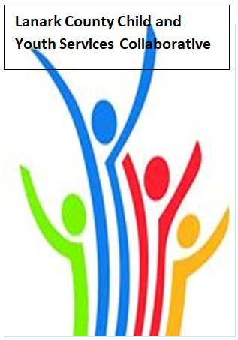

Vision: Children and youth in our communities are thriving. They are served by a well, informed, responsive and effective community of organizations.

Mission: The council provides leadership and collaboration to enable optimal development and healthy living for Lanark County children, youth and their families.

Coffee provided by Family & Children’s Services
We meet on traditional unceded Algonquin First Nation Territory, in Lanark County.

AGENDA
Dec. 5, 2019 9:30 – 12:00 – Family and Children’s Services of Lanark, Leeds and Grenville, Smiths Falls, ON
Chair: Fraser Scantlebury Coordinator: Sharon Halladay Note Taker: Cathy Clarke
Attendance:
Regrets:
Agenda item | Desired outcome | Lead | Time | Discussion and action items
Welcome  - Review Agenda  - Acceptance of Meeting Notes |  | Fraser Scantlebury | 9:30 – 9:40
Information Sharing | Share information/  PD opportunities | Participating Members | 9:40 – 10:05
Community Education |  | Randy Hillier | 10:05-10:30
Collaboration and Planning | Break |  | 10:30– 10:45
Community Education |  | Natalie Markoff  PLEO  Communications and Partnerships Director | 10:45- 11:10
Collaboration and Planning/Advocacy | Work plan Review  Dec. Survey | Sharon Halladay | 11:10 – 11:50
Community Issues Update  Key Messages and Closing |  | Erin Lee  Fraser Scantlebury | 11:50– 12:00

