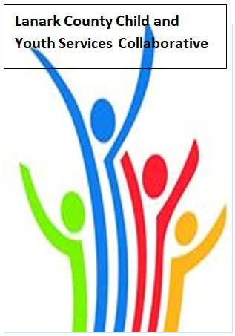

Vision: Children and youth in our communities are thriving. They are served by a well, informed, responsive and effective community of organizations.

Mission: The council provides leadership and collaboration to enable optimal development and healthy living for Lanark County children, youth and their families.

Zoom provided by United Way
We meet on traditional unceded Algonquin First Nation Territory, in Lanark County.

AGENDA
Aug. 13, 2020 9:30 – 11:00 –Virtual Zoom
Chair: Fraser Scantlebury Coordinator: Sharon Halladay Note Taker: Sharon Halladay
Attendance:
Regrets:
Agenda item | Desired outcome | Lead | Time | Discussion and action items
Welcome  - Review Agenda  - Acceptance of Meeting Notes  - Black Lives Matters follow up - FS KC |  | Fraser Scantlebury | 9:30 – 9:35
Community Education | Study: Teacher/  Student  Relationships &  Mental Health  Seeking Behaviour  among Elementary  and Secondary  Students in Ontario | Jillian Halladay  RN, BScN, MSc  PhD(c) Department of Health Research Methods, Evidence, and Impact  Part-Time Instructor, School of Nursing/ McMaster University | 9:35-10:00
Information Sharing | Share information/  PD opportunities | Participating Members | 10:00 – 10:40
Key Messages and Closing  - Second Thursday for meeting  - Directory  - New membership  - Co-chair |  | Fraser Scantlebury | 10:40– 11:00

