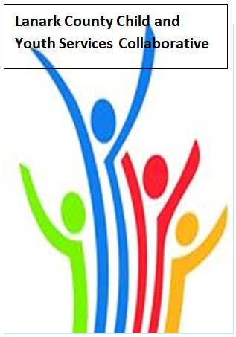

Vision: Children and youth in our communities are thriving. They are served by a well, informed, responsive and effective community of organizations.

Mission: The collaborative provides leadership and collaboration to enable optimal development and healthy living for Lanark County children, youth and their families.

Zoom provided by United Way
We meet on traditional unceded Algonquin First Nation Territory, in Lanark County.

AGENDA
Nov. 12, 2020 9:30 – 11:00 –Virtual Zoom
Chair: Sue Poldervaart Coordinator: Sharon Halladay Note Taker: Sharon Halladay
Attendance:
Regrets:
Agenda item | Desired outcome | Lead | Time | Discussion and action items
Welcome  - Review Agenda  - Acceptance of Meeting Notes |  | Sue Poldervaart | 9:30 – 9:35
Community Education | County of Lanark  Covid Recovery Plan | Emily Hollington  Road to Recovery | 9:35-10:00
Community Education/Information Sharing  Part 2 | Members will  collaborate and  discuss employment  trends and  recruiting concerns | Lisa Benoit, Director Algonquin Community Employment Center | 10:00- 10:25
Information Sharing | Share information/  PD opportunities/  Flag Concerns | Participating Members | 10:25– 10:50
Key Messages and Closing | *Ask something like to discuss | Sue Poldervaart | 10:50– 11:00
Upcoming Meeting Dates: Dec. 10, Jan. 14, Feb. 11, Mar. 11, April 8, May 13, June 10

