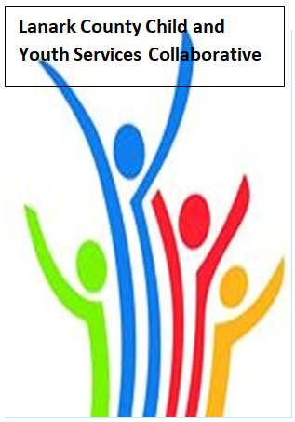

Vision: Children and youth in our communities are thriving. They are served by a well, informed, responsive and effective community of organizations.

Mission: The collaborative provides leadership and collaboration to enable optimal development and healthy living for Lanark County children, youth and their families.

Zoom provided by United Way
We meet on traditional unceded Algonquin First Nation Territory, in Lanark County.

AGENDA
April 8, 2021 9:30 – 11:00 –Virtual Zoom
Chair: Sue Poldervaart Coordinator: Sharon Halladay Note Taker: Sharon Halladay
Attendance:
Regrets:
Agenda item | Desired outcome | Lead | Time | Discussion and action items
Welcome  - Review Agenda  - Acceptance of Meeting Notes |  | Sue Poldervaart | 9:30 – 9:40
Community Education | Agency Profile  Sharing | Jane Torrance – United Way | 9:40- 9:45
Information Sharing | Share information/  PD opportunities | Participating Members | 9:45– 10:00
Community Education | Community Safety and Well-Being Plan Progress Update | Stephanie Gray | 10:00 – 10:20
Collaboration/Planning | Break out session  With questions  From presentation | Stephanie Gray | 10:20- 10:50
Key Messages and Closing  Discussion item?  Summer meetings? |  | Sue Poldervaart | 10:50– 11:00
Upcoming Meeting Dates: May 13, June 10

