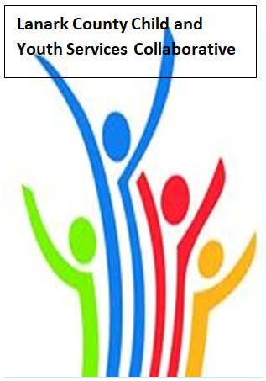

Vision: Children and youth in our communities are thriving. They are served by a well, informed, responsive and effective community of organizations.

Mission: The collaborative provides leadership and collaboration to enable optimal development and healthy living for Lanark County children, youth and their families.

Zoom provided by United Way
We meet on traditional unceded Algonquin First Nation Territory, in Lanark County.

Notes
June 10, 2021 9:30 – 11:00 –Virtual Zoom
Chair: Sue Poldervaart Coordinator: Sharon Halladay Note Taker: Sharon Halladay
Attendance: Michelle Neville, Sue Cavanagh, Tammy Kealey- Donaldson, Erin Lee Marcott, Jane Hess, Joellen McHard, Stephanie Gray, Nneka Ejiofor, Kara Symbolic, Erika Heesen, Sue Poldervaart, Ramsey Hart, Jane Torrance, Rachel Roth, Emily Gray
Regrets:
Agenda item | Desired outcome | Lead | Time | Discussion and action items
Welcome  - Review Agenda  - Acceptance of Meeting Notes  - Survey/Work Plan/Election |  | ELM or CKF  Sue Poldervaart | 9:30 – 9:35 | Land acknowledgment will happen each meeting with a different member. Erin Lee Marcott did the acknowledgment today.  Agenda and minutes accepted.  Survey will be sent out with key messages. Work plan was accepted. Sharon reminded members that we will need new members for the Stewardship.
Community Education | Mental Health Supports for Students – summer and fall | Kevin Clouthier  Alison Inglis  Michelle Neville | 9:35 – 10:05 | UCDSB – special services counsellor on call. Summer school will have two social emotional workers providing in your class and will provide virtual wellness workshops. Refamiliarization of routines will have support teams available. A wellness champion for each school. Mental Health and Addiction Nurses available throughout the summer. We hope that there is more access in the fall. Online is still an option in the fall. There have been advocates that students need to be at school and not the best for rural communities. PD for staff and short videos and some videos for parents.  CDSBEO – transition kits for Grade 6 and 8. E- learning offering certificates for grade 9-12. Update all the kits for mental health in the school. Umbrella Project pilots. PD sessions in the summer for staff. Asist, Mental Health First Aid. Social services counsellor.
Collaboration/Planning | Equity Presentation  Follow Up | Erin Lee Marcott | 10:05- 10:20 | Erin suggested that we do a tri county work group. Sharon will send out a request in the key messages. It will be about three meetings starting in September. Erin will start a resource list and Marg Fancy from EKOC for Leeds Grenville and I can share with everyone to add to it.
Community Education | Agency Profile  Sharing | Sue Cavanagh | 10:20-10:25 | Document shared in key messages. Sue shared stories of why they do the work they do.
Collaboration | Follow up on  211 presentation  discussion questions | John Hoyles | 10:25– 10:45 | Answers shared with John and the group.
Information Sharing | Share information/  PD opportunities | Participating Members  Terri Henderson – St. Paul’s  United Church | 10:45 – 10:55 | Kara Symbolic – Connectwell - shared sensitivity training opportunity for small non- profits or board members.  Terri Henderson – offering space at St. Paul’s United Church and open to all possibilities  Jane Hess –LGL Health Unit update on vaccine – week of June 14th open up to families and public. Still room in our area.  Joellen McHard - LCCJ – Please continue to end letters of support for our Law Foundation of Ontario Catalyst Application. Looking for board members.
Key Messages and Closing | Happy Summer | Sue Poldervaart | 10:55– 11:00
Upcoming Meeting Dates: Sept. 9

