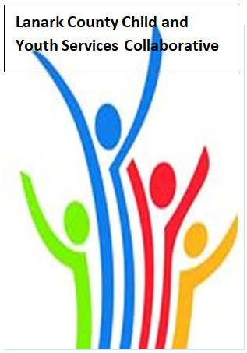

Vision: Children and youth in our communities are thriving. They are served by a well, informed, responsive and effective community of organizations.

Mission: The council provides leadership and collaboration to enable optimal development and healthy living for Lanark County children, youth and their families.

Teams provided by Open Doors
We meet on traditional unceded Algonquin First Nation Territory, in Lanark County.

AGENDA
Oct. 14 2021 9:30 – 11:00 –Virtual Zoom
Chair: Kevin Clouthier Coordinator: Sharon Halladay Note Taker: Sharon Halladay
Attendance:
Regrets:
Agenda item | Desired outcome | Lead | Time | Discussion and action items
Welcome  - Review Agenda  - Acceptance of Meeting Notes  - Equity Work Group  - Election  - I Pledge? |  | Jodi Bucholz- LIP  Kevin Clouthier  Sharon Halladay  Kevin Clouthier | 9:30 – 9:40
Community Education | Agency Profile  Carleton Place  Youth Centre | Gail Lotan | 9:40 – 9:45
Information Sharing/Community Education | Local Immigration  Partnership  Lanark/Renfrew | Jodi Bucholtz –manager | 9:45- 10:05
Collaboration/Planning | Vaccine Policy  Discussion | All members | 10:05 – 10:30
Information Sharing/Community Education | Queer Connection Lanark | Elizabeth Snider | 10:30-10:50
Information Sharing | Share information/  PD opportunities | Participating Members | 10:50-10:55
Key Messages and Closing |  | Kevin Clouthier | 10:55-11:00
Upcoming Meeting Dates: Nov. 11, Dec. 9, Jan. 13, Feb. 10, Mar. 10, April 14, May 12, June 9

