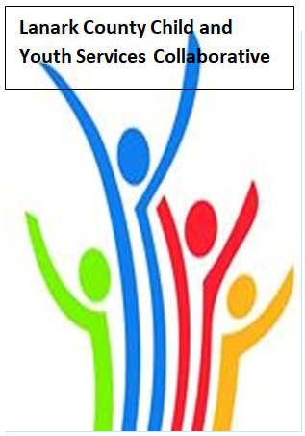

Vision: Children and youth in our communities are thriving. They are served by a well, informed, responsive and effective community of organizations.

Mission: The council provides leadership and collaboration to enable optimal development and healthy living for Lanark County children, youth, and their families.

TEAMS provided by Open Doors
We meet on traditional unceded Algonquin First Nation Territory, in Lanark County.

AGENDA
Sept. 8, 2022 9:30 – 11:00 –Virtual TEAMS
Chair: Kevin Clouthier Coordinator: Sharon Halladay Note Taker: Sharon Halladay
Attendance:
Regrets:
Agenda item | Desired outcome | Lead | Time | Discussion and action items
Welcome – Land Acknowledgement  - Review Agenda  - Acceptance of Meeting Notes  - Introduce new members  - Survey  - Work Plan  - Election next month |  | Noella Klawitter  Kevin Clouthier  Sharon Halladay | 9:30 – 9:50
Equity Update |  |  | 9:50-10:00
Agency profile | Members will be  educated on new  programs and existing  programs that the  agency provides. | Noella Klawitter  KidsInclusive | 9:50-9:55
Information Sharing | Update PD  Opportunities/Agency  Information | All Members | 10:05-10:15
Collaboration regarding emerging issues and trends | Create a list of  concerns and  opportunities that  members are dealing  with and would like  to discuss at our in  person meeting. | All Members | 10:15- 10:30
Information Sharing/Community Education | Share Planet Youth  Results and Q&A | Dr. Tanya Halsall | 10:30-10:55
Key Messages and Closing |  | Kevin Clouthier | 10:55-11:00
Upcoming Meeting Dates: Oct. 13, Nov. 10, Dec. 8, Jan. 12, Feb. 9, Mar. 9, Apr. 13, May 11, June 8

