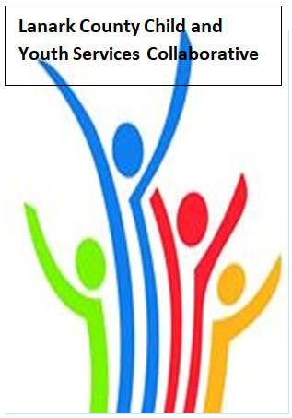

Vision: Children and youth in our communities are thriving. They are served by a well, informed, responsive and effective community of organizations.

Mission: The council provides leadership and collaboration to enable optimal development and healthy living for Lanark County children, youth, and their families.

TEAMS provided by Open Doors
We meet on traditional unceded Algonquin First Nation Territory, in Lanark County.

Notes
Dec. 8, 2022 9:30 – 11:00 –Virtual TEAMS
Chair: Chelsey Coe Coordinator: Sharon Halladay Note Taker: Sharon Halladay
Attendance: Chelsey Coe, Shannon Bruce, Elizabeth Snyder, Joellen McHard, Jennifer Miller, Sue Poldervaart, Selina Mackie, Tanya Halsall, Noella Klawitter, Stephanie Gray, Melissa Spratt, Holly Sommerville, Elaine Murkin, Marcus Dickie, Sue Cavanagh, Leslie Green, Jodi Bucholtz, Kevin Clouthier, Lori Taylor, Varlie Horsfall, Jaime Beechey, Rachel Roth
Regrets: Kelly Barry, Garry Laws, Ramsey Hart, Jeri Lynch, Sara Sark,
Agenda item | Desired outcome | Lead | Time | Discussion and action items
Welcome – Land Acknowledgement  - Review Agenda  - Acceptance of Meeting Notes  - Thank you Sue Cavanagh |  | Joellen McHard  Chelsey Coe  Kevin Clouthier | 9:30 – 9:40 | Sent with Key Messages  Accepted  Introduced Marcus Dickie, Jennifer Adams, Jennifer Miller  Great respect shared for Sue Cavanagh
Equity Update | HR Practices – Training Activity | Shannon Bruce  UWEO | 9:40-9:55 | Breakout room discussion. Resources will be shared.
Agency profile | Members will be  educated on new  programs and existing  programs that the  agency provides. | Joellen McHard  Lanark County Community Justice | 9:55-10:00 | Video shared in key messages.
Community Education/Collaboration | Queer Lanark Survey  Results/ next  steps/Discussion | Elizabeth Snyder  Lori Taylor  Erin Lee  Queer Lanark | 10:00-10:45 | Survey results sent.
Information Sharing | Update PD  Opportunities/Agency  Information | All Members | 10:45-10:55 | Erin Lee- LCIH – meeting tonight for people interested in telling stories for a movie - QCL  Panel member discussion tomorrow night at Old Town Hall in Almonte about rural inquest - $10 a ticket.
Key Messages and Closing |  | Chelsey Coe | 10:55-11:00 | Key messages  - Happy retirement Sue Cavanagh  - Is Jessica really Mrs. Claus’s first name?  - Both presentations were excellent. We need to look more at how it looks in our community.  - Great job Chelsey as first time as chair!  - We hope everyone finds a peace in their heart over the holidays. (Quote from Sue Cavanagh)
Upcoming Meeting Dates: Jan. 12, Feb. 9, Mar. 9, Apr. 13, May 11, June 8 – red indicates in person

