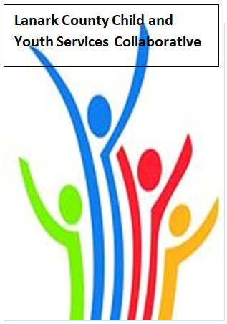

Vision: Children and youth in our communities are thriving. They are served by a well, informed, responsive and effective community of organizations.

Mission: The council provides leadership and collaboration to enable optimal development and healthy living for Lanark County children, youth, and their families.

TEAMS provided by Open Doors
We meet on traditional unceded Algonquin First Nation Territory, in Lanark County.

AGENDA
Feb. 9, 2023 9:30 – 11:00 –Virtual TEAMS
Chair: Kevin Clouthier Coordinator: Sharon Halladay Note Taker: Sharon Halladay
Attendance:
Regrets:
Agenda item | Desired outcome | Lead | Time | Discussion and action items
Welcome – Land  Acknowledgement  - Review Agenda  - Acceptance of Meeting Notes |  | Chelsey Coe – County of Lanark  Kevin Clouthier | 9:30 – 9:35
Equity Update | HR Practices – Training Activity | Dan McRae  Principal Equity and Inclusion - UCDSB | 9:35-9:45
Agency profile | Members will be  educated on new  programs and existing  programs that the  agency provides. | Chelsey Coe – County of Lanark | 9:45-9:50
Community Education | Members will learn  about two free  programs that can  support employers to  make their workplace  more inclusive for  employees and  clients. | Wessan Ayad  KEYS Manager  Learning&Development – EDI Solutions | 9:50- 10:15
Collaboration Activity | Languages of Life | Erin Lee  Director LCIH | 10:15- 10:45
Information Sharing | Update PD  Opportunities/Agency  Information | All Members | 10:45-10:55
Key Messages and Closing |  | Kevin Clouthier | 10:55-11:00
Upcoming Meeting Dates: March 9, Apr. 13, May 11, June 8 – red indicates in person

