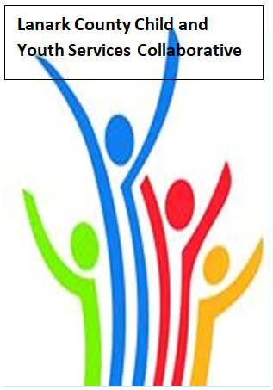

Vision: Children and youth in our communities are thriving. They are served by a well, informed, responsive and effective community of organizations.

Mission: The council provides leadership and collaboration to enable optimal development and healthy living for Lanark County children, youth, and their families.

TEAMS provided by Open Doors
We meet on traditional unceded Algonquin First Nation Territory, in Lanark County.

AGENDA
Mar. 9, 2023 9:30 – 11:30 –Virtual TEAMS
Chair: Chelsey Coe Coordinator: Sharon Halladay Note Taker: Sharon Halladay
Attendance:
Regrets:
Agenda item | Desired outcome | Lead | Time | Discussion and action items
Welcome – Land  Acknowledgement  - Review Agenda  - Acceptance of Meeting Notes |  | Sean Keogan SFPS  Chelsey Coe | 9:30 – 9:35
Equity Update | Case Study Preparation for April | Jodi Bucholz  LIP | 9:35-9:45
Agency profile | Members will be  educated on new  programs and existing  programs that the  agency provides. | Const. Sean Keogan  SFPS  Community Officer | 9:45-9:50
Collaboration | Community Resource  Guide Assistance | Samantha Snyder  (Placement student) Lanark County Community Justice | 9:50- 9:55
Community Education | Elimination of Racial  Discrimination | Jodi Bucholz  LIP | 9:55- 10:05
Community Education | Update on services with LLGAMH and the challenges they are facing. | Magean Plue LLGAMH | 10:05- 10:30
Information Sharing | Update PD  Opportunities/Agency  Information | All Members | 10:30-10:35
Key Messages and Closing |  | Chelsey Coe | 10:35:10:40
Collaboration | Follow up  presentation for  agencies interested in  accessing support  collaboratively to  create a more  inclusive workplace  environment  for staff and clients. | Charter Team and IBI Team from KEYS | 10:40- 11:40
Upcoming Meeting Dates: Apr. 13, May 11, June 8 – red indicates in person

