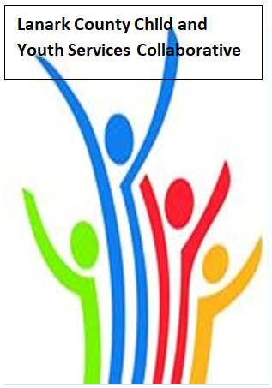

Vision: Children and youth in our communities are thriving. They are served by a well, informed, responsive and effective community of organizations.

Mission: The council provides leadership and collaboration to enable optimal development and healthy living for Lanark County children, youth, and their families.

TEAMS provided by Open Doors
We meet on traditional unceded Algonquin First Nation Territory, in Lanark County.

Notes
Feb. 9, 2023 9:30 – 11:00 –Virtual TEAMS
Chair: Kevin Clouthier Coordinator: Sharon Halladay Note Taker: Sharon Halladay
Attendance: Kevin Clouthier, Elizabeth Synder, Jodi Bucholtz, Joellen McHard, David Somppi, Amber Turcotte, Chelsey Coe, Sean Keogan, Elaine Murkin, David Somppi, Elizabeth Snyder, Erin Lee, Holly Somerville, Valerie Horsafall, Jaime Beechey, Jennnifer Miller, Jeri Lynch, Jessica Quattrocchi, Kelly Barry, Melissa Kirk, Melissa Thom, Leslie Greene, Lilli Nothnagel, Lori Taylor, Melissa Thom, Rachel Burns, Rachel Roth, Selina Mackie, Shannon Bruce, Tawnya Boileau
Regrets: Sharon Bjergso, Diane Oxborough, Stephanie Gray, Noella Klawitter, Garry Laws, Tammy Kealey Donaldson, Kara Symbolic, Joseph Tereschuk, Maegen Plue, Laurie Weir
Agenda item | Desired outcome | Lead | Time | Discussion and action items
Welcome – Land  Acknowledgement  - Review Agenda  - Acceptance of Meeting Notes |  | Chelsey Coe – County of Lanark  Kevin Clouthier | 9:30 – 9:35 | Recognition of Sue Poldervaart for her work on the Collaborative.  Agenda and notes accepted.
Equity Update | HR Practices – Training Activity | Dan McRae  Principal Equity and Inclusion - UCDSB | 9:35-9:45 | Discussed the why we need to review our hiring practices. Participant gave examples of their understanding of the why.
Agency profile | Members will be  educated on new  programs and existing  programs that the  agency provides. | Chelsey Coe – County of Lanark | 9:45-9:50 | Power point shared
Community Education | Members will learn  about two free  programs that can  support employers to  make their workplace  more inclusive for  employees and  clients. | Wessam Ayad  KEYS Manager  Learning&Development – EDI Solutions | 9:50- 10:15 | Information about services shared.
Collaboration Activity | Languages of Life | Erin Lee  Director LCIH | 10:15- 10:45 | Language lines solutions service information provided and will be shared.  Second part of activity- Words and definitions -is an activity that will be shared with the group.
Information Sharing | Update PD  Opportunities/Agency  Information | All Members | 10:45-10:55 | Joellen McHard – LCCJ – Triple P Parenting for Teens coming up  Jessica Quattrocchi –CROW- Resiliency Workshop – Bounce Back and Thrive workshop –  Leslie Greene- Connectwell – Family and Community Wellness Fair  Shannon Bruce – UWEO-Application for Community Recovery Grant – due Feb. 21  Erin Lee – LCIH- Still collecting money for BBBS – Bowl-a-thon. Accolade award for creating first ever victim advocate program.
Key Messages and Closing |  | Kevin Clouthier | 10:55-11:00 | Key Messages:  - Review hiring practices and think about our Whys  - Check out project presented by Wessam Ayad from KEYS – follow up meeting with more explanation about the program and Q&A will be organized.  - Take a chance and try equity activity presented by Erin today.
Upcoming Meeting Dates: March 9, Apr. 13, May 11, June 8 – red indicates in person

