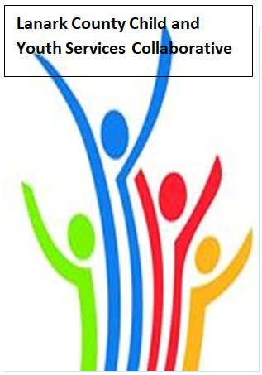

Vision: Children and youth in our communities are thriving. They are served by a well, informed, responsive and effective community of organizations.

Mission: The council provides leadership and collaboration to enable optimal development and healthy living for Lanark County children, youth, and their families.

TEAMS provided by Open Doors
We meet on traditional unceded Algonquin First Nation Territory, in Lanark County.

AGENDA
May 11, 2023 9:30 – 11:00 - Virtual
Chair: Chelsey Coe Coordinator: Sharon Halladay Note Taker: Sharon Halladay
Attendance:
Regrets:
Agenda item | Desired outcome | Lead | Time | Discussion and action items
Welcome – Land  Acknowledgement  - Review Agenda  - Acceptance of Meeting Notes |  | Diane Oxborough  Chelsey Coe | 9:30 – 9:35
Community Education | Members will be  updated on new  information and  happenings in our  community. | Michelle Bellows  Kristian Gundersen  Smiths Falls HUB | 9:35- 10:00
Community Education | Update and answer  questions regarding  the Vital Signs  Document. | Victoria Gibb- Carsley  Vital Signs | 10:00- 10:25
Community Education | Update and answer questions regarding Planet Youth. | David Sommpi  Planet Youth | 10:25 – 10:50
Information Sharing | Update PD  Opportunities/Agency  Information | Shannon Russell  FASD System Navigator  All Members | 10:50 – 10:55
Equity Update | EDI Pulse Check | Sharon Halladay  Coordinator | 10:55 – 10:57
Key Messages and Closing |  | Chelsey Coe | 10:57 – 11:00
Upcoming Meeting Dates: June 8 – Hybrid

