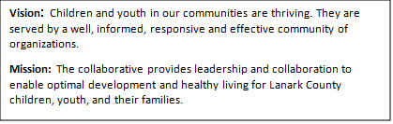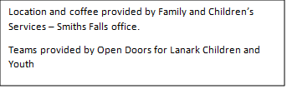

AGENDA
June 13, 2024 9:30 – 11:30
Chair: Kevin Clouthier/Chelsey Coe Coordinator: Sharon Halladay Note Taker: Sharon Halladay
Attendance:
Regrets:
Agenda item | Desired outcome | Lead | Time | Discussion and action items
Welcome – Land  Acknowledgement  - Welcome – round table introduction  - Review Agenda  - Acceptance of Meeting Notes  - Survey/Workplan  - Election |  | Chelsey Coe  Lesley Greene  ConnectWell Community Health  Kevin Clouthier  Sharon Halladay  Rachel Burns | 9:30 – 9:40
Agency profile | Members will be  educated on new  programs and existing  programs that the  agency provides. | Lesley Greene  ConnectWell Community Health | 9:40 - 9:45
Information Sharing/Community Education | EDI update | Jodi Bucholtz | 9:45 – 9:50
Information Sharing | Cindy Dawson 1 call 1 Click | Cindy Dawson | 9:50 10:10
Information Sharing | First Place Options | Rick  ED First Place Options | 10:10-10:20
Coffee Break |  |  | 10:20-10:35
Information Sharing | OHT update | Morgan Hawn | 10:35 –10:55
Collaboration | Case Study | All members | 10:55 – 11:25
Information Sharing | Update PD  Opportunities/Agency  Information | All Members | 11:25 - 11:28
Key Messages and Closing |  | Kevin Clouthier | 11:28 -11:30
Upcoming Meeting Dates: Sept. 12

