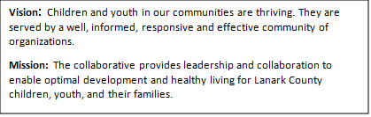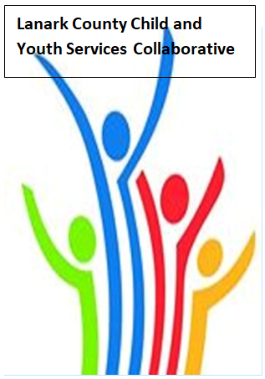
TEAMS - Open Doors Mental Health
AGENDA
Feb. 8 2026 9:30 – 11:00
Virtual - TEAMS

Chair: Chelsey Coe Coordinator: Sharon Halladay Note Taker: Sharon Halladay
Attendance:
Regrets:
Agenda item | Desired outcome | Lead | Time | Discussion and action items
Welcome – Land  Acknowledgement  - Welcome  - Review Agenda  - Acceptance of Meeting Notes  - March In person |  | Gabriella Salera - LIP  Chelsey Coe | 9:30 – 9:35
Information Sharing | CDSBEO update | Selina Mackie | 9:35- 9:55
Agency profile | Members will be  educated on new  programs and existing  programs that the  agency provides. | LIP - Gabriella Salera | 9:55-10:00
Information Sharing/Community Education | EDI - Reflection on Lunch and Learn | Erin Lee Marcotte | 10:00- 10:20
Information Sharing | Ministry of CCSS update | Tiffany Belkin | 10:20-10:35
Information Sharing | Youth Wellness Hub | Ken Inbar, David Sommpi | 10:35- 10:55
Information Sharing | Hearing Unheard Moments | Joey Graff, David Sommpi | 10:55-11:05
Information Sharing | Update PD  Opportunities/Agency  Information | All Members | 11:05- 11:08
Key Messages and Closing |  | Chelsey Coe | 11:08- 11:10
Upcoming Meeting Dates: Mar. 12, April 9, May 14, June 11.

