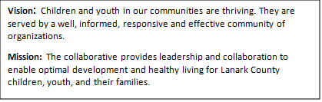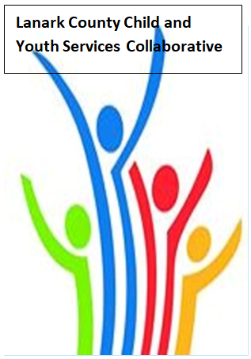
Location and Coffee - Family and Children’s Services /TEAMS - Open Doors Mental Health
AGENDA
March 12, 2026 - 9:30 – 11:30
Family and Children’s Service Office
385 Hwy 29, Smiths Falls, ON K7A 4W7
Chair: Chelsey Coe Coordinator: Sharon Halladay Note Taker: Sharon Halladay
Attendance:
Regrets:
Agenda item | Desired outcome | Lead | Time | Discussion and action items
Welcome – Land  Acknowledgement  - Welcome  - Review Agenda  - Acceptance of Meeting Notes  - Update on Community Safety Working Group- HUM – Crisis Response Communication Plan  - Municipal Tool Kit/Developmental Asset Awards |  | CP Youth Centre  Sharon Ruth  Chelsey Coe  Erika Heesen  Sharon Halladay | 9:30 – 9:35
Agency profile | Members will be  educated on new  programs and existing  programs that the  agency provides. | Carleton Place and District Youth Centre- Sharon Ruth | 9:35-9:40
Information Sharing/Community Education | EDI -How to advocate  for local communities to  better support  indigenous populations | David Laviolette - OPP | 9:40– 10:00
Information Sharing | Smiths Falls response to Food Insecurity Emergency | Mayor Shawn Pankow | 10:00-10:20
Information Sharing | Role in health care and the social determinants of health - FNIMUI | Celina Tuttle  Perth Family Health Team | 10:20-10:40
Collaboration | Coffee Break |  | 10:40- 10:50
Information Sharing | Marketing ideas for attracting youth | Cathy McNally | 10:50- 11:10
Collaboration | Discussion | What have we learned today? | 11:10- 11:25
Information Sharing | Update PD  Opportunities/Agency  Information | All Members | 11:25- 11:28
Key Messages and Closing |  | Chelsey Coe | 11:28-11:30
Upcoming Meeting Dates: April 9, May 14, June 11.

