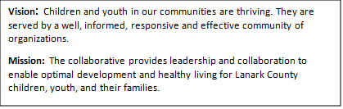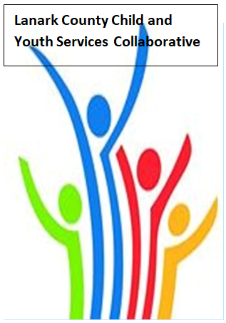
TEAMS - Open Doors Mental Health
Notes
Feb. 8 2026 9:30 – 11:00
Virtual - TEAMS

Chair: Chelsey Coe Coordinator: Sharon Halladay Note Taker: Sharon Halladay
Attendance: Chelsey Coe, Tiffanie Belkin, David Somppi, Diane Oxborough, Elizabeth Snyder, Emily Tubbs, Erin Lee Marcotte, Sharon Ruth, Karen Forbes, Gabriella Salera, Jennifer Miller, Joey Graff, Judith Peak, Ken Inbar, Joellen McHard, Leslie Greene, Lilli Nothnagel, Lisa Jackson, Logan Noonan, Melanie Rocheleau, Nicki Collins, Leah Nielsen, Corey Noonan, Rachel Burns, Sara Jane Manning, Sean Keogan, Selina Mackie, Stephanie Gray, Erika Heesen, David Laviolette, Rachel Roth
Regrets: Sharon Bjergso, Sarah Sark, Kellie Weir-Burtt,
Agenda item | Desired outcome | Lead | Time | Discussion and action items
Welcome – Land  Acknowledgement  - Welcome  - Review Agenda  - Acceptance of Meeting Notes  - March In person |  | Gabriella Salera - LIP  Chelsey Coe | 9:30 – 9:35 | Acceptance of meeting agenda and notes.
Information Sharing | CDSBEO update | Selina Mackie | 9:35- 9:55 | Power point shared
Agency profile | Members will be  educated on new  programs and existing  programs that the  agency provides. | LIP - Gabriella Salera | 9:55-10:00 | Power point shared
Information Sharing/Community Education | EDI - Reflection on Lunch and Learn | Erin Lee Marcotte | 10:00- 10:20 | Power point shared
Information Sharing | Ministry of CCSS update | Tiffanie Belkin | 10:20-10:35 | Power point shared
Information Sharing | Youth Wellness Hub | Ken Inbar, David Sommpi | 10:35- 10:55 | Power point shared
Information Sharing | Hearing Unheard Moments | Joey Graff, David Sommpi | 10:55-11:05 | Power point shared
Information Sharing | Update PD  Opportunities/Agency  Information | All Members | 11:05- 11:08 | Stephanie Grey: I wanted to remind folks about the training the Lanark County Situation Table has organized with Dr. Chad Nilson on Feb. 24 from 9-3 online. It is for upstream risk detection specific to youth and is geared to situation table member agencies, but also to those child-serving organizations who are in a position to detect risk in youth. Here is the link: https://www.eventbrite.ca/e/1981793943032?aff=oddtdtcreator  Risk Detection: Specific to Youth Workshop  Training and guidance around risk detection specific to youth.
Key Messages and Closing |  | Chelsey Coe | 11:08- 11:10 | Key Messages:  - David Somppi: There are lots of opportunities provincially and federally that we are not taking advantage of, and we all should be  - Elizabeth Snyder: The term, “Hearing Unheard Moments.” We all need to remember this, and do this. Tied in beautifully with Erin Lee Marcotts presentation.  - Best of Luck to Ken on his retirement.
Upcoming Meeting Dates: Mar. 12, April 9, May 14, June 11.

