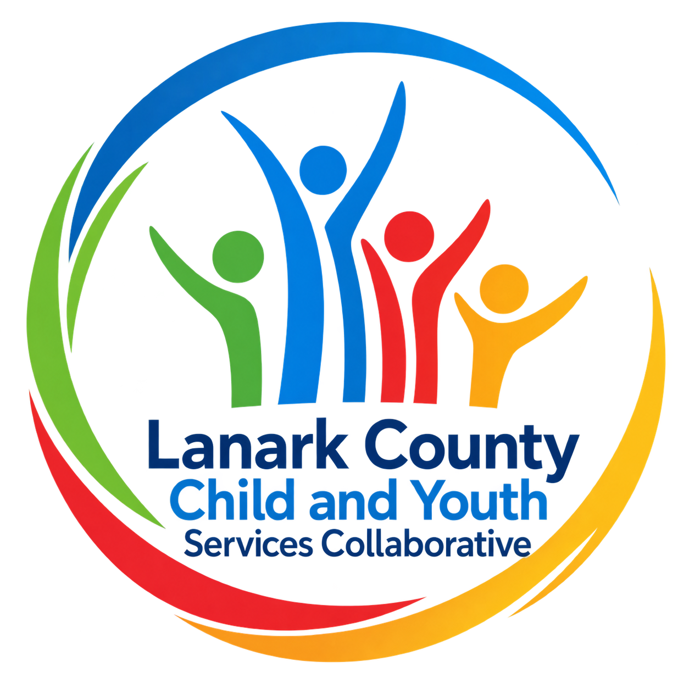
LANARK COUNTY
CHILD AND YOUTH SERVICES
COLLABORATIVE
MEMBERSHIP PACKAGE
2026–2027

Working together so children, youth and families across Lanark County and the Town of Smiths Falls can thrive.

Membership • Governance • Working Groups • Meeting Schedule • Common Terms

Welcome to the Collaborative
The Lanark County Child and Youth Services Collaborative (LCC) brings together organizations, agencies and community partners that share a commitment to improving outcomes for children, youth and families across Lanark County and the separated Town of Smiths Falls.
Through information sharing, collaborative planning, community education and advocacy, members work together to identify emerging needs, strengthen connections between services and develop coordinated responses to issues affecting children, youth and families.
This Membership Package provides an overview of the Collaborative, membership expectations, governance structure, working groups, meeting schedules and common terminology to support meaningful participation in LCC.

LCC at a Glance
Geographic Area | Lanark County, including rural communities and town centres, and the separated Town of Smiths Falls.
Membership | Organizations and agencies serving children, youth and families. Representatives are generally senior leaders or individuals authorized to speak on behalf of their organization.
Collaborative Meetings | Second Thursday of the month, September through June, except December. No regular meetings in July or August.
Working Groups | Issue-specific or project-specific groups formed to respond to identified community needs and priorities.
Decision-Making | Consensus is preferred. Voting may be used when consensus cannot be reached.
Community Coordinator | Supports agendas, minutes, research, information sharing, orientation and the work of the Collaborative and its working groups.

Vision
Children and youth in our communities are thriving. They are served by a well-informed, responsive and effective community of organizations.

Mission
The Collaborative provides leadership and collaboration to enable optimal development and healthy living for Lanark County children, youth and their families.

Core Priorities
- Information Sharing
- Collaboration and Planning
- Community Education and Advocacy

Commitment to Inclusion
Equity, diversity, inclusion and belonging are embedded in the Collaborative’s planning, decision-making, partnerships and community engagement.

Membership

Who Participates
Membership is open to agencies and organizations that serve children, youth and families in Lanark County and/or the Town of Smiths Falls. Membership is intended to provide broad cross-sector representation while maintaining the Collaborative’s effectiveness and accountability as a community planning body.

Member Expectations
- Attend meetings regularly and come prepared to participate.
- Represent the perspective, knowledge and priorities of the member organization or sector.
- Share relevant information from LCC with the member’s organization, network or sector.
- Bring emerging community needs, trends, service gaps and opportunities to the Collaborative.
- Participate in collaborative planning, community education and advocacy where appropriate.
- Contribute to working groups or time-limited initiatives when possible.
- Respect confidentiality, differing perspectives and the principles of collaborative decision-making.
- Identify actual, potential or perceived conflicts of interest.

What Members Can Expect
- Timely information about community initiatives, services, trends and emerging issues.
- Opportunities to build relationships across sectors and strengthen service coordination.
- A forum for identifying community needs and developing collaborative responses.
- Opportunities to participate in advocacy, public education and joint initiatives.
- Access to the knowledge and expertise of a broad network of community partners.
- Orientation and support from the Community Coordinator.

New Member Process
- An interested agency or organization identifies a representative.
- The Community Coordinator circulates the name of the agency/organization and representative to LCC members.
- Members have two weeks to identify any concerns.
- If no concerns are raised, the proposed membership is submitted to the Stewardship Committee.
- The Community Coordinator sends an invitation and completes an orientation with the new member.

Alternates
An alternate may attend and vote when the Collaborative is notified of the alternate’s attendance before the meeting.

Member Organizations
The following list is based on the current membership package and should be confirmed annually for official organization names and active membership.
Big Brothers Big Sisters of Lanark County
Catholic District School Board of Eastern Ontario
Children’s Resources on Wheels (CROW)
ConnectWell Community Health
Cornerstone Landing Youth Services
County of Lanark
Family and Children’s Services of Lanark, Leeds and Grenville
Food for Thought Lanark County
KidsInclusive / Kingston Health Sciences Centre
Lanark County Community Justice Program
Lanark County Interval House
Lanark County Mental Health
Lanark County Situation Table
Lanark Safe Families
South East Health Unit
Lanark, Leeds and Grenville Addictions and Mental Health
Libraries of Lanark County
Local Immigration Partnership – Lanark/Renfrew
Ministry of Children, Community and Social Services
Open Doors Mental Health
Ontario Provincial Police
Perth & District Community Foundation
PLEO – Parents’ Lifelines of Eastern Ontario
Planet Youth – Lanark County
Queer Connections Lanark
Rideau Community Health Services – Smiths Falls Community Health Centre
RNJ Youth Services
Rural FASD Support Network of Eastern Ontario
Smiths Falls Ministerial Association
Smiths Falls Police Service
The Table Community Food Centre, Perth
Trellis Mental Health
United Way East Ontario
Upper Canada District School Board
Victim Services – Lanark County
Youth Centre Coalition
• Mississippi Mills Youth Centre (MMYC) – Almonte
• CORE Youth Services – Carleton Place
• Lanark Highlands Youth Centre (LHYC)
• YAK Youth Services – Perth
• WAK Youth – Smiths Falls
Youth Habilitation Quinte Inc. (Youthab)

Terms of Reference

1. Name and Mandate
Lanark County Child and Youth Services Collaborative, referred to in these Terms of Reference as “the Collaborative.”
The Collaborative provides a county-wide forum for leadership, coordination, planning, information sharing, community education and advocacy related to children, youth and families.

2. Guiding Principles
1. Children, youth and families require a long-term community commitment to creating and maintaining the best possible conditions for healthy development and well-being.
2. The needs of all children, youth and families must be acknowledged and addressed. Those experiencing increased vulnerability or requiring additional supports should receive appropriate attention and resources.
3. Children, youth, families, community supports, service providers and other stakeholders should be meaningfully engaged in identifying needs, setting direction, providing leadership and building community capacity.
4. Health and well-being are strengthened by high-quality, coordinated and accessible programs, services and information that are available as close to home as possible.
5. Relationships based on goodwill, mutual respect, open-mindedness and shared purpose support innovation and strengthen the community.
6. Timely and open sharing of information, knowledge and expertise supports effective planning and decision-making.
7. Equity, diversity, inclusion and belonging, together with meaningful youth and family voice, should inform the Collaborative’s work.

3. Priorities and Responsibilities

Information Sharing
- Promote access to timely, appropriate and coordinated services, information and programs.
- Identify priorities and opportunities to better serve children, youth and families.
- Increase awareness, coordination and collaboration among service providers, funders, families and community supports.
- Establish communication mechanisms that keep members informed and engaged.
- Support members in sharing relevant Collaborative information with their respective organizations and sectors.

Collaboration and Planning
- Work collectively with stakeholders to identify needs, monitor trends and anticipate emerging vulnerabilities.
- Build collaborative plans on the strengths, expertise and resources available across Lanark County and Smiths Falls.
- Support coordinated community responses to identified issues.

Community Education and Advocacy
- Speak with a strong and unified voice on common issues affecting children, youth and families.
- Advocate for common interests while keeping the needs of children, youth and families at the forefront.
- Provide objective and evidence-informed advice to funders, policymakers and community stakeholders.
- Provide input to regional planning processes based on identified local needs.
- Increase public awareness through proactive community education and engagement.

Governance and Decision-Making

Collaborative
- Identifies issues and explores action plans.
- Works with community partners, working groups and regional processes to advance agreed priorities.
- Represents Lanark County interests at relevant regional tables.
- Functions as an advisory and community planning group.
- Supports information flow across sectors and levels of service.
- Reviews the Membership Package and Terms of Reference annually in September.

Co-Chairs and Members-at-Large
Co-Chairs and Members-at-Large are selected in accordance with the Collaborative’s approved governance process. Elected positions are normally confirmed in October for a one-year term. Where more than one candidate seeks a position, a majority of 50% plus one determines the outcome.
Governance note: The Collaborative should confirm the designated transfer-payment agency Co-Chair position and the exact Stewardship composition before final approval of this package.

Decision-Making
The Collaborative will pursue consensus whenever possible. Consensus means members can accept a decision after concerns and objections have been heard, understood and considered. Consensus does not require complete agreement.
When consensus cannot be reached, the Chair may call a vote. Decisions are made by simple majority (50% plus one) of voting members present, provided quorum is met. If a vote is tied, the Chair may vote.

Quorum and Voting
- A quorum is 12 voting members.
- Proxy voting is not permitted.
- Approved alternates may vote when advance notice of their attendance has been provided.
- Electronic voting may be used for urgent matters, subject to the same quorum requirements.
- Voting membership and organizational representation will be reviewed annually.
Governance note: The existing package contains inconsistent wording about whether voting is one vote per member or one vote per member organization. This should be formally confirmed and the final wording inserted here.

Conflict of Interest
A conflict of interest exists when a member is, or may reasonably be perceived to be, in a position to influence a decision that could provide a personal advantage or an advantage to an organization in which the member has a direct role or financial interest.
Members are expected to disclose actual, potential or perceived conflicts of interest as soon as they become known. Where appropriate, the member will refrain from participating in discussion or voting on the matter. The declaration and any action taken will be recorded in the meeting minutes.

Accountability
The Collaborative is accountable to its membership while recognizing the existing accountability of members to their boards, organizations, funders and communities. Consistent participation supports continuity, shared understanding and the Collaborative’s ability to achieve its goals. Working groups are accountable to the full Collaborative.

Stewardship Committee
The Stewardship Committee supports the effective operation of the Collaborative. It works with the Community Coordinator to prepare agendas, identify emerging issues, support work planning and provide general operational direction between Collaborative meetings.

Core Functions
- Support development of Collaborative meeting agendas.
- Provide general direction and support to the Community Coordinator.
- Identify emerging issues and recommend items for Collaborative consideration.
- Support development and monitoring of the annual work plan.
- Support appropriate stewardship of the Collaborative’s available resources and budget, within authority approved by the full Collaborative.
Governance note: The final Terms of Reference should clearly identify which decisions Stewardship may make independently and which require approval of the full Collaborative.

Community Coordinator
- Works with the Co-Chairs and Stewardship Committee to develop agendas.
- Prepares and distributes meeting materials and minutes.
- Researches issues and provides information requested by the Collaborative.
- Supports working groups and special initiatives.
- Coordinates new-member orientation and membership communication.
- Supports connections with other child and youth planning tables and regional partners.

Working Groups
Working groups are created around specific issues, priorities or projects. Participation is voluntary and may include LCC members, managers, front-line staff, community partners, parents, caregivers and youth. Membership in a working group does not require membership in the full Collaborative.
Each working group should have a clear purpose, identify a Chair or lead, report regularly to the Collaborative and operate within the direction or mandate approved by LCC. Time-limited ad hoc groups may be created for short, defined activities.

Community Issues Working Group
Purpose | Identifies and responds to emerging community issues; supports Calls to Action and advocacy priorities identified by the Collaborative.
Membership | Interested LCC members and Community Coordinator
Meeting Frequency | As needed

Equity, Diversity & Inclusion Working Group
Purpose | Supports understanding of equity and diversity, inclusive leadership, and the development of inclusive systems and processes.
Membership | LCC and Every Kid in Our Community Planning Table members
Meeting Frequency | Monthly

Building Safety Working Group
Purpose | Strengthens youth engagement, safety and inclusion; improves information flow about resources and supports; builds community trust and youth capacity to resolve conflict.
Membership | Interested LCC members, Community Coordinator and community partners as appropriate
Meeting Frequency | Every two months

Asset Builder Awards Working Group
Purpose | Recognizes Lanark County residents and community members who make a positive impact on children, youth and families. The annual recognition ceremony is held in June.
Membership | Interested LCC members, Community Coordinator and EKIOC members
Meeting Frequency | Monthly during planning period

2026–2027 Meeting Schedule
The Collaborative meets on the second Thursday of the month. Virtual meetings run from 9:30–11:00 a.m.; in-person meetings run from 9:30–11:30 a.m. January and February meetings are virtual. There are no regular meetings in December, July or August.
During winter months, if school buses are cancelled, an in-person LCC meeting is also cancelled unless the meeting is moved to a virtual format.
Month | Collaborative | Stewardship
September | Sept. 10 | Sept. 3
October | Oct. 8 | Oct. 1
November | Nov. 12 | Nov. 5
December | No meeting | No meeting
January | Jan. 14 – Virtual | Jan. 7
February | Feb. 11 – Virtual | Feb. 4
March | Mar. 11 | Mar. 4
April | Apr. 8 | Apr. 1
May | May 13 | May 6
June | June 10 | June 3
July/August | No meetings | No meetings

Stewardship Meetings
The Stewardship Committee meets virtually on the first Thursday of the month. The meeting time is determined by the members and may be adjusted as required.

Common Acronyms and Terms
Acronym | Meaning
BBBS | Big Brothers Big Sisters
CAMH | Centre for Addiction and Mental Health
CDC | Child Development Centre
CDSBEO | Catholic District School Board of Eastern Ontario
CHC | Community Health Centre
CROW | Children’s Resources on Wheels
CYHNEO | Child and Youth Health Network of Eastern Ontario
CYPAN | Child and Youth Poverty Action Network
EDI | Equity, Diversity and Inclusion
FCSLLG | Family and Children’s Services of Lanark, Leeds and Grenville
KFL&A | Kingston, Frontenac and Lennox & Addington
LCC | Lanark County Child and Youth Services Collaborative
LCCJP | Lanark County Community Justice Program
LCIH | Lanark County Interval House
LLGAMH | Lanark, Leeds and Grenville Addictions and Mental Health
LIP | Local Immigration Partnership
LHYC | Lanark Highlands Youth Centre
MCCSS | Ministry of Children, Community and Social Services
MMYC | Mississippi Mills Youth Centre
ODSP | Ontario Disability Support Program
OPP | Ontario Provincial Police
OW | Ontario Works
PLEO | Parents’ Lifelines of Eastern Ontario
RNJ | RNJ Youth Services
SFCHC | Smiths Falls Community Health Centre
UCDSB | Upper Canada District School Board
YAK | YAK Youth Services

Annual Review and Approval
The Membership Package and Terms of Reference will be reviewed annually at the first meeting in the fall to ensure they continue to reflect the mandate, membership, governance and structure of the Lanark County Child and Youth Services Collaborative.
Last Reviewed | September 2026
Approved by the Collaborative | ____________________________
Next Scheduled Review | September 2027

Items to Confirm Before Final Approval
- Confirm the final voting rule: one vote per member organization or one vote per individual member.
- Confirm the exact composition of the Stewardship Committee and designated transfer-payment agency representation.
- Confirm the decision-making authority of Stewardship, particularly budget approval.
- Verify all member organization names and active membership for 2026–2027.
- Confirm whether non-voting/ex officio membership categories remain required.
- Confirm the official names and mandates of all active working groups.

