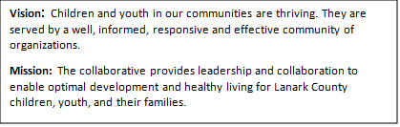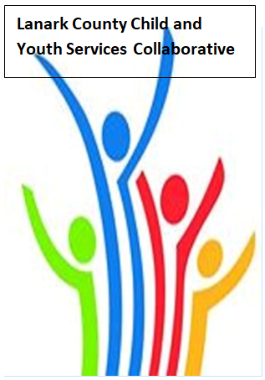
Location and Coffee - Family and Children’s Services /TEAMS - Open Doors Mental Health
Notes
June 11th, 2026 - 9:30 – 11:30
Family and Children’s Service Office
385 Hwy 29, Smiths Falls, ON K7A 4W7
Chair: Melissa Leveck Coordinator: Sharon Halladay Note Taker: Sharon Halladay
Attendance: Erika Heesen, Rachel Burns, Rebecca Shams, Sara Jane Manning, Elizabeth Snyder, Selina Mackie, Rachel Roth, Beth O’Halloran, Gabriella Salera, Lisa Jackson, Tracy Charette, Mackenzie Kada, Conner Crane, Julia Limbay, Joellen McHard, Erin Lee Marcotte, Coral Sproule, Erin Lee, Corey Noonan, Stephanie Gray, David Somppi, Holly Watson
Regrets: Chelsey Coe, Sharon Ruth, Jordan Blanchard, Diane Oxborough, Berta Madrigal Abaroa,

Agenda item | Desired outcome | Lead | Time | Discussion and action items
Welcome – Land  Acknowledgement  - Welcome  - Review Agenda  - Acceptance of Meeting Notes  - Developmental Asset Awards  - Survey |  | Coral Sproule - The Table  Melissa Leveck  Sharon Halladay | 9:30 – 9:35 | One change in agenda noted.  Asset Builder Awards at County of Lanark building on June 24. We have 17 nominations.  Survey has been sent out and will be sent out a few more times. The information guides our work plan. Please complete by June 30th.
Agency profile | Members will be  educated on new  programs and existing  programs that the  agency provides. | The Table - Coral Sproule | 9:35-9:40 | Power point shared
Information Sharing | CP Coalition | Sarah Cavanagh | 9:40– 9:55 | Unable to attend but message read by Melissa and forwarded to the members of the collaborative.
Information Sharing | EDI survey | Gabriella Salera | 9:55-10:15 | Members completed. Link sent to those not in attendance.
Information Sharing | Community Safety Working Group - Communication Plan Update | Stephanie Gray | 10:15-10:20 | Members agreed to make the communication plan permanent.  Erin Lee warned about privacy concerns. David suggested that after a crisis when the communication plan is used that there should be a review.
Collaboration | Coffee Break |  | 10:20- 10:35
Information Sharing | Unravelling the Moment | Erin Lee  Elizabeth Snyder | 10:35- 11:00 | Power point shared
Collaboration | Case Study | All Members | 11:00- 11:25
Information Sharing | Update PD  Opportunities/Agency  Information | All Members | 11:25- 11:28 | Time did not allow for sharing so members were encouraged to send items to Sharon to be shared.
Key Messages and Closing |  | Melissa Leveck | 11:28-11:30 | - Complete survey links for EDI and LCCYSC work plan.  EDI - https://app.sli.do/event/dQWDcqKT3rA5wvTgUADdmf  LCCYSC - https://docs.google.com/forms/d/e/1FAIpQLScmrfHPmW66nbR15TmCa698rqJHrsJj-Pk1l61wHa7AVqYT5g/viewform?usp=header  - Being there for the community. We are needed so much!  - Chilled curiosity  - Have a great summer. See you Sept. 10!
Upcoming Meeting Dates: Sept. 10, 2026

